**COURSE TITLE**

CUA30720 Certificate III in Design Fundamentals

**SUBJECT TITLE**

A10154 The Design Process

**TRAINING UNITS**

A: CUADES201 Follow a design process

B: CUADES301 Explore the use of colour

C: CUADES302 Explore and apply the creative design process to 2D forms

**ASSESSMENT TASK 1**

**Design Workbook**

Student name:

Student number:

Email address:

**The Design Process**

**Contents**

1. The Design Brief 3

2. Schedule 4

3. Critical Analysis 5

4. Design Development 8

5. Colour Theory 14

6. Feedback 19

7. WHS 20

8. References 21

9. Additional Pages 22

Submission Instructions 23

## **1. The Design Brief**

Read Assessment Tasks 1 and 2. Complete the template below with the design brief requirements.

|  |  |
| --- | --- |
| **Design Brief** | |
| Project Name/Event |  |
| Client (*e.g. Trainer*) | {Who are you designing for?} |
| Due Date | {What is the deadline for completing the task?} |
| Audience | {Who will the design communicate to?} |
| Responsibility | {What is your role and responsibility in completing this brief?} |
| Objectives | {What do you need to achieve?}  List at least 2. |
| Constraints | {What restrictions might you come across when completing this task?}  List at least 2. |
| Resources Required | {What resources will you need to complete the task?}  List at least 3. |

## **2. Schedule**

Read Assessment Tasks 1 and 2. Use the table below to schedule key tasks and deadlines for both assessment tasks.

You may add or delete rows as required.

| **Task Description** | **DEADLINE** | **Tools/Materials/Equipment Required** |
| --- | --- | --- |
|  |  |  |
|  |  |  |
|  |  |  |
|  |  |  |
|  |  |  |
|  |  |  |
|  |  |  |
|  |  |  |
|  |  |  |
|  |  |  |
|  |  |  |
|  |  |  |

## **3. Critical Analysis**

Research event poster designs and select one poster that you like. Critically analyse it for the use of the colour.

Insert your chosen poster here and answer the questions below.

|  |
| --- |
|  |

Answer the questions below by writing a minimum of 3-4 sentences in response to each question.

| 3.1. Who is the artist/designer? |
| --- |
|  |

| 3.2. Where did you find the poster? List the source using the *Harvard Referencing Style* ([www.citethisforme.com](http://www.citethisforme.com)) |
| --- |
|  |

| 3.3. What is the poster trying to communicate? |
| --- |
|  |

| 3.4. Which colours have been used? |
| --- |
|  |

| 3.5. What do these colours communicate or represent? |
| --- |
|  |

| 3.6. How is this relevant to what the poster is trying to communicate? |
| --- |
|  |

| 3.7. What Elements and Principles of Design have been used in this poster design? List at least 3. |
| --- |
|  |

| 3.8. Do you think that the poster communicates its idea successfully? Explain why? |
| --- |
|  |

## **4. Design Development**

Begin working on your poster design for Assessment Task 2 ‘Design Brief’.

Answer the questions below and use the following pages to insert your design development for the design brief in Assessment Task Two.

You may insert scanned or photographed pages, photographs, mood boards, sketches, or anything else that shows your design development.

Show a minimum of two (2) unique concepts in your design development. You may add or delete pages as required.

| 4.1. What creative thinking techniques have you used in your design development process? List at least 2. |
| --- |
|  |

| 4.2. Design is a way of thinking and solving problems. What are the key steps in the design process? |
| --- |
|  |

|  |
| --- |
| {Design Development} |

|  |
| --- |
| {Design Development} |

|  |
| --- |
| {Design Development} |

|  |
| --- |
| {Design Development} |

|  |
| --- |
| {Design Development} |

## **5. Colour Theory**

Answer the questions below:

| 5.1. Research colour and write a short paragraph on how colour might be used to communicate a particular idea or concept. |
| --- |
|  |

| * 1. List at least two (2) sources of information using the *Harvard Referencing Style* ([www.citethisforme.com](http://www.citethisforme.com)) |
| --- |
|  |

| * 1. Colour psychology suggests that colours can influence our emotions and our behaviour. What might be a limitation with following this traditional colour theory in design? List at least one (1) answer. |
| --- |
|  |

| * 1. Traditional colour theory suggests that certain colours work better together depending on their placement on the colour wheel.  What might be a limitation with following this traditional colour theory in design? List at least one (1) answer. |
| --- |
|  |

**Colour Experimentation**

Complete some colour experiments using various colour combinations that you think will work well together and communicate your idea for the design brief. Submit a minimum of 3 options.

You may complete these digitally and insert them here or you may complete them by hand using markers, pencils, or paints, and insert them as a scanned or photographed image.

An example from *‘Dictionary Of Colour Combinations - Volume 2*’ has been provided below:

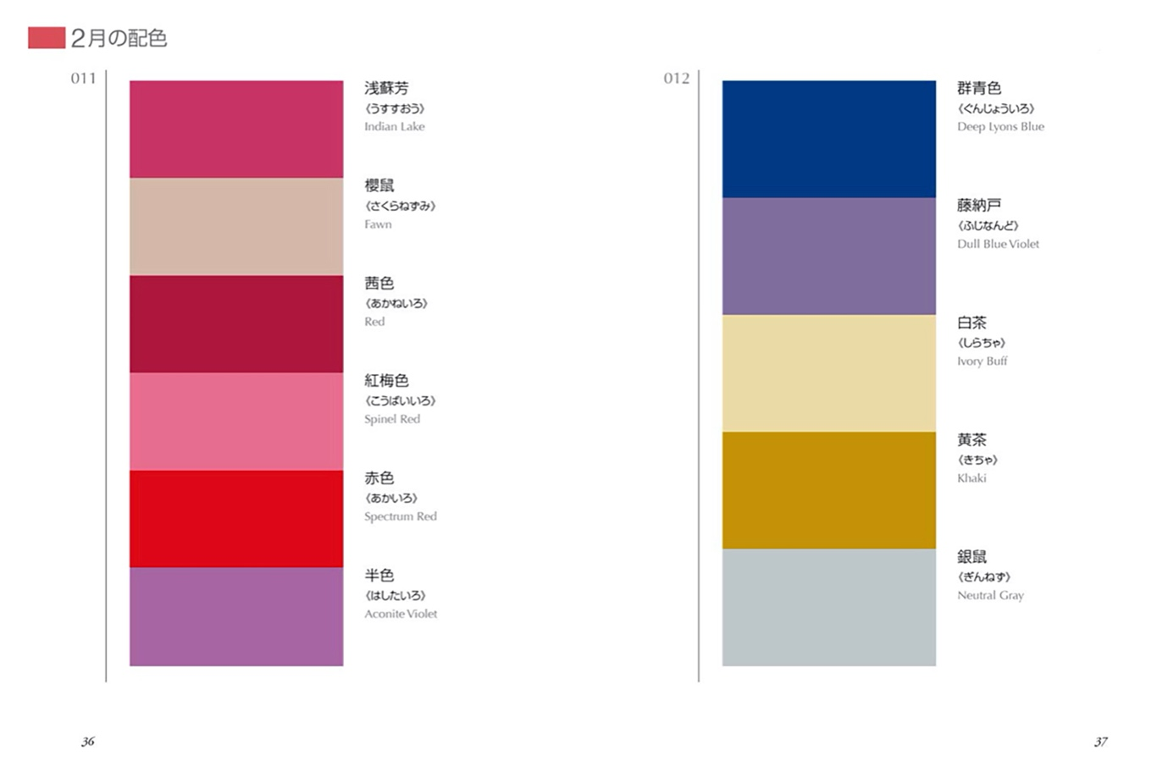

|  |
| --- |
| {Colour Experimentation} |

|  |
| --- |
| {Colour Experimentation} |

For each of your colour experiments, answer the following questions with a minimum of 3 sentences:

| * 1. Why do you think these colours work well together? |
| --- |
|  |

| * 1. Why do you think these colours will work in communicating your concept? |
| --- |
|  |

## **6. Feedback**

Book a feedback session with your trainer during Studio Time to discuss your design development and ideas for progressing to Assessment Task 2.

In response to the feedback session, write a paragraph in answer to each of these questions:

| 6.1. What was the feedback you received on your initial ideas and your use of colour? |
| --- |
|  |

| 6.2. How are you going to use the feedback to move forward with your poster designs? |
| --- |
|  |

| 6.3. Which concepts did your trainer encourage you to move forward with? Why? |
| --- |
|  |

| 6.4. Did you identify any problems or challenges with your design? If so, what are they? |
| --- |
|  |

## **7. WHS**

Using the table below, list any tools, materials, or equipment you have used.   
You will also need to list the steps you have taken you ensure you have worked in a safe way.

This may include, but is not limited to: Any necessary personal protective equipment used *or* safe work practices when sitting at a desk, for example.

You may add or delete rows as required.

| Tool, Material or Equipment used | Measures taken to ensure safe use |
| --- | --- |
|  |  |
|  |  |
|  |  |
|  |  |
|  |  |
|  |  |
|  |  |
|  |  |
|  |  |
|  |  |
|  |  |
|  |  |

## **8. References**

You must list *all*sources of information in the ‘references’ section of this workbook.

Include books, websites, magazines, or any other sources of information you have gathered in order to complete your assessment task.   
APC use the *Harvard Referencing Style* ([www.citethisforme.com](http://www.citethisforme.com))

See additional resource for referencing requirements.

## **9. Additional Pages**

You may insert additional pages as evidence at the end of the workbook if necessary.

## **Submission Instructions**

1. To submit this workbook, complete all activities in this workbook.
2. Save it as a PDF.
3. Use the naming convention: FirstLast_A10154_AT1_DDMMYY
4. Go to the Submissions Area in myAPC.hub and select ASSESSMENT TASK 1. Submit your work.